Job vacancy link :
https://karir.bca.co.id/karir/detail/bca-development-program-it-bdp-it

TIAS HAFIDZOTUL LUTHFIANA
21161562005

Campurdarat, Tulungagung

Head Of HRD  PT Bank Central Asia Tbk  Jakarta | December 12, 2024

Dear HRD Manager,

I am writing to express my keen interest in the BCA Development Program (BDP-IT). My name is Tias Hafidzotul Luthfiana, As a recent graduate of the Informatics Study Program from Bhinneka PGRI University in November 2024, enthusiastically apply to join the BCA Development Program (BDP-IT). During my studies, I have equipped myself with strong knowledge in programming, information systems, and databases. My GPA of 3.94 reflects my ability to understand complex technical concepts.

In addition, I am also actively involved in various projects, such as application development, research, and competitions involving programming. Through these projects, I have honed my problem-solving, teamwork, and critical thinking skills. I am very interested in the BDP-IT program because I see this as an excellent opportunity to develop myself and contribute directly to the progress of the banking industry in Indonesia. This program aligns with my desire to learn from experts in the field of information technology and become part of a dynamic and innovative team.


I am confident that my high curiosity to learn, adaptability, and the knowledge I have gained during my studies will be valuable assets for the BDP-IT program. I am ready to fully commit during the program and provide the best contribution to BCA. Thank you for your time and attention. I have attached a resume containing details of my qualifications and experience. I really hope to be part of the BDP-IT program and can't wait to take part in the next selection process.

Best regards,

Tias Hafidzotul Luhfiana

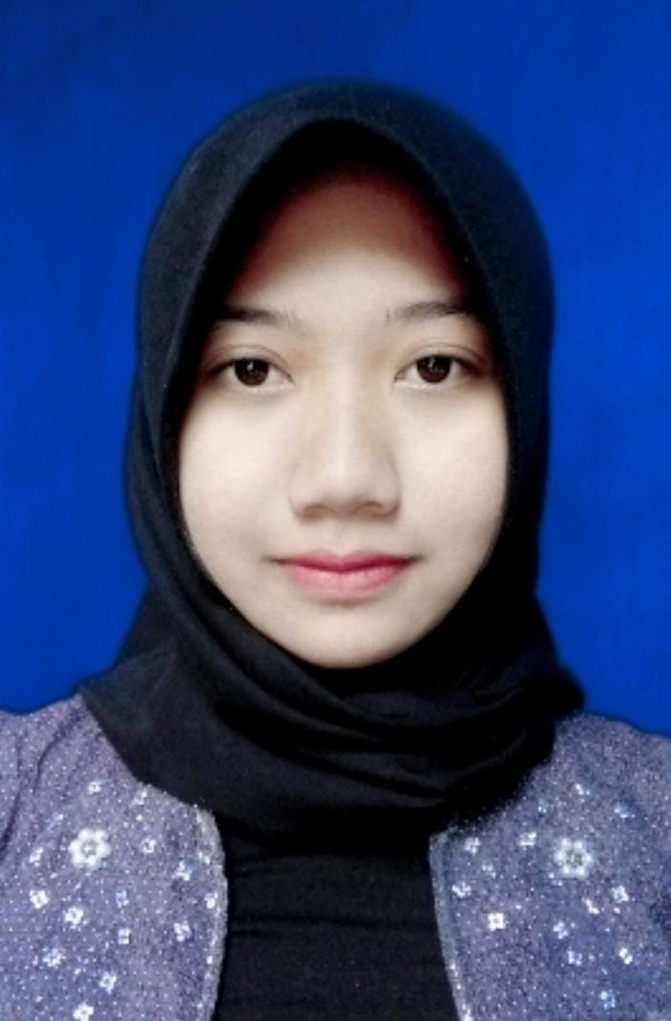
TIAS HAFIDZOTUL LUTHFIANA

tiashluthfiana@gmail.com |
+6282228163135 |
Campurdarat, Tulungagung |

BCA Development Program IT (BDP IT)

Head Of HRD  PT Bank Central Asia Tbk  Jakarta | December 12, 2024

Dear HRD Manager,

I am writing to express my strong interest in the BCA Development Program (BDP-IT). As a recent graduate of the Informatics Study Program from Bhinneka PGRI University in November 2024, I am eager to leverage my academic foundation and passion for technology to contribute to a leading financial institution like BCA.

BCA's commitment to innovation and fostering a culture of continuous learning deeply resonates with my aspirations. The BDP-IT program particularly excites me because it offers a unique opportunity to:

Develop my skills under industry experts: I am eager to gain hands-on experience and learn from BCA's experienced professionals in the IT field. Contribute to meaningful projects: I am highly motivated to apply my skills and knowledge to real-world projects, contributing to BCA's continued success in the ever-evolving banking landscape. Build a successful career in IT: The BDP-IT program aligns perfectly with my long-term goal of building a thriving career in the IT sector of a leading financial institution. During my studies, I focused on software development, data analytics, and information security. I actively participated in projects like developing a web application, analyzing financial data, and conducting research on cybersecurit, which honed my skills in programming languages, data analysis tools, problem-solving, and teamwork. Additionally, my GPA 3.94 reflects my dedication to academic excellence and my ability to grasp complex technical concepts.

My strong technical skills, combined with my passion for technology, eagerness to learn, and adaptability, make me a strong candidate for the BDP-IT program. I am confident that I can quickly become a valuable asset to your team and contribute positively to BCA's growth and innovation.

Thank you for considering my application. I have attached my resume for your review, detailing my qualifications and experiences further. I am very enthusiastic about this opportunity and welcome the chance to discuss my potential contributions during an interview.

Sincerely,

Tias Hafidzotul Luthfiana

